**WEEK - 2**

**UNIT TESTING**

**TDD using JUnit5 and Mockito**

**JUNIT Basic Testing Exercise**

**MANDATORY**

**Exercise 1: Setting Up JUnit**

**Scenario:** You need to set up JUnit in your Java project to start writing unit tests.

**Steps:**

1. Create a new Java project in your IDE (e.g., IntelliJ IDEA, Eclipse).

2. Add JUnit dependency to your project. If you are using Maven, add the following to your pom.xml: junit junit 4.13.2 test

3. Create a new test class in your project.

**Output:**

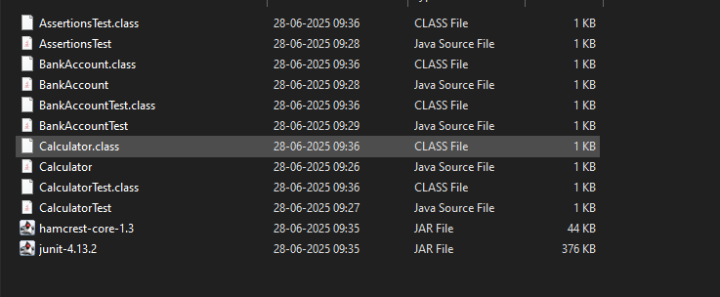

**Exercise 2: Writing Basic JUnit Tests**

**Scenario:** You need to write basic JUnit tests for a simple Java class.

**Code:**

Calculator.java

**public** **class** Calculator {

**public** **int** add(**int** a, **int** b) {

**return** a **+** b;

    }

**public** **int** subtract(**int** a, **int** b) {

**return** a **-** b;

    }

**public** **int** multiply(**int** a, **int** b) {

**return** a **\*** b;

    }

**public** **int** divide(**int** a, **int** b) {

**if** (b **==** 0) **throw** **new** IllegalArgumentException("Division by zero");

**return** a **/** b;

    }

}

CalculatorTest;

**import** **static** **org.junit.Assert.\***;

**import** **org.junit.Test**;

**public** **class** CalculatorTest {

**Calculator** calc **=** **new** Calculator();

    @**Test**

**public** **void** testAdd() {

        assertEquals(5, calc.add(2, 3));

    }

    @**Test**

**public** **void** testSubtract() {

        assertEquals(1, calc.subtract(4, 3));

    }

    @**Test**

**public** **void** testMultiply() {

        assertEquals(6, calc.multiply(2, 3));

    }

    @**Test**(expected **=** IllegalArgumentException.class)

**public** **void** testDivideByZero() {

        calc.divide(5, 0);

    }

    @**Test**

**public** **void** testDivide() {

        assertEquals(2, calc.divide(6, 3));

    }

}

**Output:**

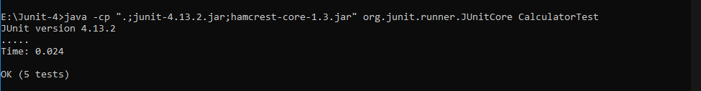

**MANDATORY**

**Exercise 3: Assertions in JUnit**

**Scenario:** You need to use different assertions in JUnit to validate your test results.

**Code:**

Assertion.java

**import** **static** **org.junit.Assert.\***;

**import** **org.junit.Test**;

**public** **class** AssertionsTest {

    @**Test**

**public** **void** testAssertions() {

*// Assert equals*

        assertEquals(5, 2 **+** 3);

*// Assert true*

        assertTrue(5 **>** 3);

*// Assert false*

        assertFalse(5 **<** 3);

*// Assert null*

        assertNull(**null**);

*// Assert not null*

        assertNotNull(**new** Object());

    }

}

**Output:**

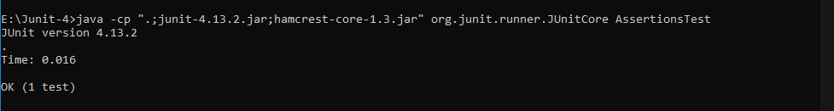

**MANDATORY**

**Exercise 4: Arrange-Act-Assert (AAA) Pattern, Test Fixtures, Setup and Teardown Methods in JUnit**

**Scenario:** You need to organize your tests using the Arrange-Act-Assert (AAA) pattern and use setup and teardown methods.

**Code:**

**public** **class** BankAccount {

**private** **int** balance **=** 0;

**public** **void** deposit(**int** amount) {

**if** (amount **>** 0)

            balance **+=** amount;

    }

**public** **void** withdraw(**int** amount) {

**if** (amount **<=** balance)

            balance **-=** amount;

    }

**public** **int** getBalance() {

**return** balance;

    }

}

**Output:**

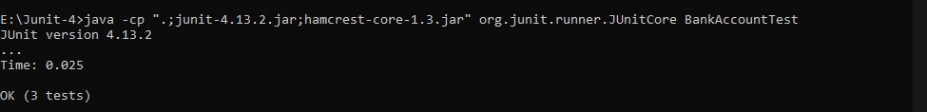

**Mockito exercises**

**MANDATORY**

**Exercise 1: Mocking and Stubbing**

**Scenario:** You need to test a service that depends on an external API. Use Mockito to mock the external API and stub its methods.

**Code:**

EXTERNALAPI.java

**public** **interface** ExternalApi {

**String** getData();

**String** getData(**String** type);

**void** saveData(**String** data);

}

MYSERVICES.java

**public** **class** MyService {

**private** **ExternalApi** api;

**public** MyService(**ExternalApi** api) {

        this.api **=** api;

    }

**public** **String** fetchData() {

**return** api.getData();

    }

**public** **String** fetchTypedData(**String** type) {

**return** api.getData(type);

    }

**public** **void** save(**String** data) {

        api.saveData(data);

    }

}

MYSERVICETEST.java

**import** **org.junit.jupiter.api.Test**;

**import** **org.mockito.InOrder**;

**import** **org.mockito.Mockito**;

**import** **static** **org.mockito.Mockito.\***;

**import** **static** **org.junit.jupiter.api.Assertions.\***;

**public** **class** MyServiceTest {

***// Exercise 1: Mocking and Stubbing***

    @**Test**

**public** **void** testMockingAndStubbing() {

**ExternalApi** mockApi **=** Mockito.mock(ExternalApi.class);

        when(mockApi.getData()).thenReturn("Mock Data");

**MyService** service **=** **new** MyService(mockApi);

        assertEquals("Mock Data", service.fetchData());

    }

***// Exercise 2: Verifying Interactions***

    @**Test**

**public** **void** testVerifyInteraction() {

**ExternalApi** mockApi **=** Mockito.mock(ExternalApi.class);

**MyService** service **=** **new** MyService(mockApi);

        service.fetchData();

        verify(mockApi).getData();

    }

*// Exercise 3: Argument Matching*

    @**Test**

**public** **void** testArgumentMatching() {

**ExternalApi** mockApi **=** Mockito.mock(ExternalApi.class);

        when(mockApi.getData(anyString())).thenReturn("Matched");

**MyService** service **=** **new** MyService(mockApi);

        service.fetchTypedData("example");

        verify(mockApi).getData(eq("example"));

    }

*// Exercise 4: Handling Void Methods*

    @**Test**

**public** **void** testVoidMethod() {

**ExternalApi** mockApi **=** Mockito.mock(ExternalApi.class);

**MyService** service **=** **new** MyService(mockApi);

        service.save("Data");

        verify(mockApi).saveData("Data");

    }

*// Exercise 5: Multiple Return Values*

    @**Test**

**public** **void** testMultipleReturns() {

**ExternalApi** mockApi **=** Mockito.mock(ExternalApi.class);

        when(mockApi.getData())

            .thenReturn("First")

            .thenReturn("Second");

**MyService** service **=** **new** MyService(mockApi);

        assertEquals("First", service.fetchData());

        assertEquals("Second", service.fetchData());

    }

*// Exercise 6: Verifying Interaction Order*

    @**Test**

**public** **void** testInteractionOrder() {

**ExternalApi** mockApi **=** Mockito.mock(ExternalApi.class);

**MyService** service **=** **new** MyService(mockApi);

        service.fetchData();

        service.save("Ordered");

**InOrder** inOrder **=** inOrder(mockApi);

        inOrder.verify(mockApi).getData();

        inOrder.verify(mockApi).saveData("Ordered");

    }

*// Exercise 7: Void Method with Exception*

    @**Test**

**public** **void** testVoidMethodException() {

**ExternalApi** mockApi **=** Mockito.mock(ExternalApi.class);

        doThrow(**new** RuntimeException("Boom")).when(mockApi).saveData("fail");

**MyService** service **=** **new** MyService(mockApi);

        assertThrows(RuntimeException.class, () **->** service.save("fail"));

        verify(mockApi).saveData("fail");

    }

}

**Output:**

